**H-ACID PLANT AUDIT REPORT**

**WRITTEN BY**

**HUSSEIN OPARI**

**CONTACT +254724526207**

By

Name

Student Registration Number

Institution Details

Course Details

Lecture

Date of Submission

# **1. EXECUTIVE SUMMARY**

This report analyses H-Acid plant operation in terms of sets of various management functions like strategic management, organizational structure, communication channels, employee concern training and development, workload management, maintenance system, health and safety procedures, environmental practices, stock management, cost discipline, and performance control. The overriding purpose of this assessment is to create a performance improvement plan that points to the areas where the operations have room for improvement. Through close examination of every detail, our goal is to identify areas of improvement and schedule appropriate performance training programs. Two main objectives – to provide for stable income growth and to increase the initial sum of money invested – are the most important. Using a well-rounded approach to analysis, the document generates practical instructions that consider the steps of business progress to the most significant effect.

# **2. ACKNOWLEDGEMENTS**

Heartfelt appreciation is extended to all persons who provided the material and data analyzed in this assessment by aiding the completion of this process. The endeavor to get the support and concurrence of the various stakeholders was paramount as they helped make the findings more comprehensive. Knowledge sharing is among the wisest and most valuable actions they have done. This has greatly enhanced the final evaluation's richness and diversity. Also, the integrated efforts among every one of us representing the value and essence of teamwork, which seeks the ever-necessary or endless growth and development of the community, are usually, knowledge, and appreciated at a rate comparable to no other.

**TABLE OF CONTENTS**

**1. EXECUTIVE SUMMARY** 2

**2. ACKNOWLEDGEMENTS** 3

**3. INTRODUCTION** 6

3.1 BACKGROUND 6

3.2 THE BRIEF 6

3.3 REPORT FORMAT 6

4. OBJECTIVES AND SCOPE 7

4.1 OBJECTIVES 7

4.2 SCOPE 8

5. METHODOLOGY 9

5.1 STRUCTURED INTERVIEWING 9

5.2 DATA ANALYSIS 9

5.3 BENCHMARKING DATA COMPARISON 10

5.4 COLLATION OF INFORMATION / RATING METHOD / RECOMMENDATIONS 10

5.5 PRESENTATION AND REPORT WRITING 11

6. RESULTS OF THE PERFORMANCE REVIEW 11

6.1. GENERAL 11

6.2. STRATEGY AND POLICY 13

6.3. ORGANISATION 14

6.4. COMMUNICATION 15

6.5. WORKLOAD MANAGEMENT 16

6.6. MAINTENANCE REGIME 17

6.7. H & S AND QUALITY 17

6.8. MATERIALS MANAGEMENT 18

6.9. VALUE FOCUS 20

6.10. MEASURES OF PERFORMANCE 21

7. RECOMMENDATIONS 27

7.1 BACKGROUND 27

7.2 PROPOSED PERFORMANCE IMPROVEMENT PROGRAMMER 28

7.3 COST/BENEFIT ANALYSIS 30

**8.** CONCLUSION 33

APPENDIX 1. INTERVIEW RESPOND 1 35

APPENDIX 2. INTERVIEW RESPOND 2 36

APPENDIX 3. INTERVIEW RESPOND 3 37

APPENDIX 4. INTERVIEW RESPOND 4 38

APPENDIX 5. INTERVIEW RESPOND 5 39

APPENDIX 6. INTERVIEW RESPOND 40

APPENDIX 7: FINANCIAL ANALYSIS 41

APPENDIX 8: PERFORMANCE CUBE 42

APPENDIX 9 MATURITY SCORES AND BENCH MARK DATA 43

# **3. INTRODUCTION**

## 3.1 BACKGROUND

In The factory operates within the industrial textile sector, being the focal entity that oversees production cycles and provides operational services. It performs top management functions, namely, managing significant performance indicators such as yield, availability, and quality. To begin with, particular accomplishments such as the completion of the H- Acid project have given the factory a status of successful business management leadership that attracts customers due to excellent service, reasonable price, and the careful client-centered approach with a net profit of £4. 3M and a 13% annual ROI.

The strategic framework that the production cycles of the factory follow is to deliver absolute efficiency optimized output. It is a systematic approach, with materials procurement, place manufacturing, quality control, and delivery. Introducing each staging to "keep" the unnecessary waste and "maximize" production is precisely how this process works.

Regarding industrial operations, the factory is devised to coordinate effectively with the departments Some manufacturing processes include procurement, production planning, inventory management, quality assurance, and so on. Adequate communication infrastructure and systemized management systems for handling various operations smoothly and making optimal decisions in the time frame.

The factory focuses on cost performance, with strict controls to track and control production costs. All aspects of business operations are encompassed by the implemented measures such as raw material sourcing, door-to-door postage, workforce utilization, and the company infrastructure meant to do away with unnecessary expenses. Continuous budget shedding allows one to focus on enhancing performance and cost savings further.

The factory comprises expert workers, technicians, engineers, and office staff. All roles are necessary to have all operations tenability. Training programs and evaluation systems aim to give employees specific skills and knowledge that they may use to discharge their duties effectively. Teamwork and collaboration are highly valued since the latter creates the right ambiance in the workspace that stimulates the mind to work.

.

## 3.2 THE BRIEF

The evaluation reviews maintenance needs, examines the current performance using audits, and creates customized recommendations to improve efficiency. It will appraise predictive and responsive maintenance, spares management and reliability of equipment aiming to outline possibilities for further enhancement. Through the examination of non-operational, compliance, and productivity targets, the evaluation aims to bring about improved maintenance measures efficiency resulting in increased production. Advice can be directed, for instance, to be technologically derived, optimized schedules and planned out maintenance. The aim is to raise the level of servicing and lifting it up to the superior quality level, contemplate innovation and excellence. The selection of a systems approach involving targeted interventions for the plant results in its towering efficiency, dependability, and lucrativeness, which render it a runaway leader in the industry.

The objective is clear: to dig out the prospects for improvement, to scrutinize aggressiveness fields that may be targeted, and to increase the implied earnings and ROI—going over poor management and identifying its wrongs is only the beginning. My evaluation aims to catalyze the plant's remarkable improvement—to become a shining outlander of innovation and excellence.

## 3.3 REPORT FORMAT

In line with specific objectives, we determine this report to be in a structured format broken down into four steps to 8. Every chapter of this analysis section addresses a separate task that gives a complete view of the operations; on the other hand, it results in actionable recommendations that can be utilized in the practice

Section 4: This section is about the aims and scope: Spell out the objectives that will be evaluated, define the scope of the assessment, and describe the border within which the analysis will be performed.

Methodology 5: To show the procedure of monitoring the performance, a methodology has been described, covering the phase of information gathering, analysis, and benchmarking.

Section 6: Outcomes of the performance review: This segment brings readers up to the findings related to the operational spaces having high-performance indicators and the low-performing spaces, using the performance review as a reference point to identify areas of improvement.

Section 7: Suggestions: Following this, the report offers changes to improve the likelihood of success and reduce the likelihood of risks recommended below.

Section 8: Finally, conclusions summarize vital points, which will be done by indicating how proposed bids address the transparency of supply chain issues and the current challenges the plant is encountering.

# **4. OBJECTIVES AND SCOPE**

## 4.1 OBJECTIVES

This evaluation aims to identify current performance in fundamental areas of maintenance and operation and, in turn, identify the areas of development and their impact on the business's future success. The process entails apprehension and measuring possibilities in an already sustainable position where the best industry practices are met. The system analysis shall provide methods and organizational structures to improve and reduce regulatory scrutiny, possessing the imperative to prevail on operational costs and capital expenditure. The action plan or the roadmap will be laid out, and there will be different approaches to coordinating different implementation methods. Moreover, any improvements should be directed firstly to the safety, integrity, and operation of the transportation corridors, which will provide a basis for sustainable development.

## 4.2 SCOPE

This paper aimed to determine the maintenance cycle and planned conditioned-based, predictive, and corrective practices. The interviews covered all the regional offices and the significant locations representing each region. The report examined the operations from the capacity perspective, considering the variations due to geographic factors and shop conditions. This exercise aims to achieve this by drawing lessons from various geographical locations and operation environments. This aims to provide a holistic understanding of maintenance performance and identify areas that need improvement with specific regional and operational details in mind.

The examination of the management process begins with a macro-level approach that aims to establish strategic fundamentals that will ensure a holistic system approach of the plant to the competitive nature of global business; it then zooms into the micro-level approaches, which are the key to the implementation of strategy as a detailed approach to day-to-day execution. Specifically, the scope encompasses:

* Strategy: The main idea and various flights of the first of the plant clearly define the nature of establishing the business.
* Organization: The providers of financial resources and activities such as issuance of bonds, management of assets, and distributions to shareholders.
* Communication: The channels and mechanical elements through which information passes in organizations and how it crosses boundaries.
* Employee Involvement: How to increase the level of engagement and empowerment within the staff, which are considered at the core of the organizational culture.
* Workload Management: Nevertheless, the principles of the techniques and systems involved in optimizing materials usage and task order.
* Maintenance Regime: The strategies and protocols that focus on keeping the assets and equipment vital to the operation healthy, safe, and effective.
* Health, Safety, and Environmental Practices: The implemented measures intended to ensure crew safety and minimize environmental impact by ensuring proper pollution mitigation.
* Materials Management: The procedures and practices for procuring materials and supplies per their utility and necessary disposal.
* Value Focus: The connection of operational behaviors with the integrated strategic purposes and shareholder stock returns.
* Performance Measures: To ensure the effectiveness and efficiency of operations, metrics, and indicators track operational goals and objectives.

Broad searches and quality rings by this evaluation aim to show a detailed view of the plant operations, which will become the base from which we can make credible decisions to increase performance.

# 5. METHODOLOGY

## 5.1 STRUCTURED INTERVIEWING

The methodology applied in this performance evaluation was a simple interview with critical actors, including employees, workers, and supervisors within the enterprise. These stakeholders included senior personnel from various departments such as operations, maintenance, engineering, and quality assurance: These stakeholders included senior personnel from various departments such as operations, maintenance, engineering, and quality assurance:

• Plant Manager – Mr. David Hyde.

• Plant Engineer – Ian Frazerz

• Planner – Jim McCand.

• Consumer - Brian Hardacre

• Hughie –

• Electrical Technician – Ian Dick

Using an interview approach, some qualitative knowledge was obtained about matters surrounding the modern state of plant operations, problems arising, and prospects for next-level growth (See Appendix 1 to 6, interview respondents 1 to 6). Structured interviews were suitable as they established the parameters for collecting the relevant data without jeopardizing consistency in questioning all the participants. This type of study yielded the plant's biological process from the perspective of people with a deep-felt connection with its regular functioning (Johnson & Onwuegbuzie, 2004).

## 5.2 DATA ANALYSIS

The focus of the analysis conducted for this assessment was centred on both qualitative and quantitative data measuring plant production and financial results indicators. Data points like yield, availability, quality, maintenance price, and profit, to be exact, were used to gather the overall picture and define trends and patterns behind the numbers. The collection of so much information is subject to the scrutinizing process at which the management can identify the areas of solid points and weak points of the facilities. Besides, the study showed the way of measuring the influence of different resources on financial results, which led to a process of making more informed decisions and making priority decisions.

## 5.3 BENCHMARKING DATA COMPARISON

Through areal benchmarking, networking, and performance data, work practices and expertise are systematically compared against the leading indicators of industry leaders. It includes measures of the target company to trace its performance metrics and identify the similarities and differences of its operation with the industry benchmarks and best practices. One of the most important indicators used in maintenance management is the key performance indicator (KPI), which includes downtime, maintenance costs, equipment reliability, and overall equipment effectiveness (OEE) concerning industry standards.

This analysis attempts to establish areas where the company is less competitive against industry leaders if there is another theme. This disparity in performance implies that the target company may have a weakness or defect in one aspect of its venture that is compared unfavorably with the situation of its peers. Further, the qualitative features of working practices, such as methods for maintenance, safety systems, and cultural significance of the organization, are discussed in light of industrial standards.

Thus, discovering the rationale behind the gap in performance provides the target company with an opportunity to comprehend the spots where improvements are needed and creates the grounds for developing focused strategies to increase performance. It could be developing the best practices for application, process improvement, investment in technology upgrades, or ensuring the workforce is capacitated through training and development programs. As firms are now aware of the best performance within the industry, this can be used for continuous improvement towards a world-class status. (Kaplan & Norton, 1996).

## 5.4 COLLATION OF INFORMATION / RATING METHOD / RECOMMENDATIONS

Combining the gathered data and a unique scoring system proved to be a crucial factor in the recipe for ranking, helping to determine the severity of various plant performance issues. We created a presentable landscape picture of the plant's performance using structured interviews, quantitative analysis, and benchmark parts of the production to enable quick comparison. This grouping process entailed organizing this compiled information on related nodal points corresponding to the evaluated aspects, including strategy development, organizing system, brush-hog regime, and quality management.

This established the following: a distinct rating method used to rate various aspects using performance indicators. They provided qualitative assessment about functioning in different fields and easy identification of successful factors and issues avoiding. Through a rating method based on a scale of unreputed value of 0 to 5, higher scores would denote excellent performance, and low scores would indicate areas where attention should be brought to.

Eventually, after the results of the rating are evaluated, the specific recommendations for the molding and shaping of the strategies to be applied were recommended after the analysis of the found gaps and taken into consideration the listed opportunities. These recommendations were tailored to align with the plant's challenges and to seek ways to push its potential to greater heights. They, as one whole, comprised tactical tools aimed at maximizing production activities, heightening productivity, and reducing threats, creating a platform for these plants for future growth, and taking advantage of the competitive advantages in the marketplace.

## 5.5 PRESENTATION AND REPORT WRITING

The analysis depicted in Figure 1, illustrating the ten assessment areas, is derived from a comprehensive evaluation of the plant's organizational processes, strategy and policy issues, maintenance regime, health, safety, environmental practices, materials management, and overall performance measures. This evaluation involved a systematic review of various facets of the plant's operations, conducted through a combination of data collection methods, including interviews, site visits, document reviews, and benchmarking against industry standards and best practices.

To evaluate the actual situation of the plant, each of the ten areas was meticulously examined to identify strengths, weaknesses, opportunities, and threats (SWOT analysis). This involved scrutinizing existing policies, procedures, and practices related to organizational structure, communication, employee empowerment, workload management, maintenance strategies, health, safety, environmental protocols, and materials management practices.

The evaluation process included:

* Organizational Analysis: Assessing the organizational structure, responsibilities, communication channels, and employee empowerment initiatives to determine areas of strength and opportunities for improvement.
* Strategy and Policy Issues: Review existing strategies and policies related to maintenance, safety, and environmental practices to identify gaps and areas requiring enhancement, such as proactive maintenance approaches and spending policies.
* Maintenance Regime Evaluation: Analyzing the current maintenance practices, including planned and reactive work, to identify opportunities for implementing reliability-centered maintenance and predictive techniques for enhancing equipment reliability and performance.
* Health, Safety, and Environmental Practices: Evaluating the effectiveness of existing policies and procedures in ensuring workplace safety, environmental compliance, and quality control while identifying areas for improvement.
* Materials Management Assessment: Examining inventory management practices, supplier partnerships, and cost-effectiveness measures to streamline materials management processes and optimize resource utilization.

The evaluation process involved a holistic approach, considering quantitative data, such as performance metrics and financial indicators, and qualitative insights gathered through interviews and observations. By systematically assessing each area of the plant's operations, the evaluation aimed to provide a comprehensive understanding of the current situation and identify targeted areas for improvement to drive efficiency and effectiveness.

Figure 1:the ten areas of the assessment

## 6.2. STRATEGY AND POLICY

Below is a statistical analysis of the "Strategy and Policy" aspect based on the provided ratings: Each item in "Strategy and Policy" is evaluated by its proximity to desired attributes and finished by scores. Classification ranged from 0.5 (less compliant) to 5 (very compliant), while students were classified from 1 (highest level) to 5 (lowest level). For example, "Management Strategy" scores 4 when there is an understandable and compelling strategic direction that many people share. Under the "limited spend" strategy, a lower score might be achieved due to the possibility of budgetary and regulatory policies imposing constraints on technical maintenance.

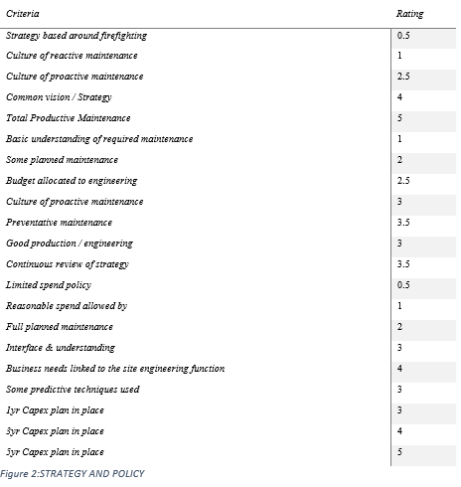

Figure 2:STRATEGY AND POLICY

**Average Rating:** The average rating for the "Strategy and Policy"

Average Rating = (0.5 + 1 + 2.5 + 4 + 5 + 1 + 2 + 2.5 + 3 + 3.5 + 3 + 3.5 + 0.5 + 1 + 2 + 3 + 4 + 3 + 3 + 4 + 5) / 21 = 2.67

1. The allocation of ratings in the "Strategy and Policy" department details a range of technicalities of this plant's business routine. Notably, the average rating of 2.67 suggests the blended picture of two faces; one is smiling while the other has pouting lips, which informs both the solid areas and the growth opportunities. For instance, evaluating the non-teaching activity involves a well-aligned leader and the plant's strategic direction, which is evidence of effective leadership.

On the contrary, the score of 0.5, according to the "Limited spend policy," points out one of the substantial problems that budget allocation faces, perhaps portraying hardship in attendance to technical maintenance because of the budgetary disadvantages. In particular, this score highlights the necessity of strategic amendments to ensure maintenance costs are appropriately subsidized while considering costly offsets.

Using the strengths and weaknesses extracted from scores offers even more of an online experience with actionable suggestions. The rating "Total Productive Maintenance" at number 5 points out an area of excellence in the plant. It demonstrates the state-of-the-art maintenance strategy to capitalize on maximum output and equipment uptime. The financially low 0.5 value for "(Strategy mainly focused on putting out fires)" highlights the company's reactive strategy, which may escalate situations beyond repair. Therefore, early proactive measures need to be put in place.

We could work to improve and align with this plant's specific challenges and opportunities by identifying focus areas that include a better appreciation of maintenance needs and a more constructive culture for proactive maintenance. Through the resolution of these critical areas, the plant and reactive maintenance will be an instrument that helps the organization develop quickly and perform better. At the same time, spoiling risks associated with the practices.

## 6.3. ORGANISATION

The scoring is based on specific criteria reflecting the organization's structure and practices. Lower ratings indicate deficiencies in predetermined engineering resources, responsibility allocation, and clarity of roles. Higher ratings suggest strengths in personal performance measures and flexibility of staff. The assessment considers factors such as resource allocation, accountability, training, and collaboration to provide a comprehensive evaluation of the organization's effectiveness and efficiency in managing its engineering and maintenance functions.

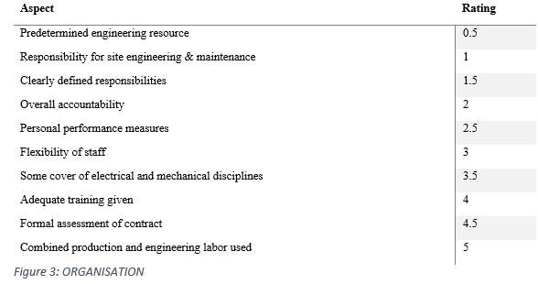Figure 3: ORGANISATION

The organization's predetermined engineering resource and responsibility for site engineering & maintenance scored low at 0.5 and 1, respectively, indicating areas needing improvement.

* However, the presence of clearly defined responsibilities (1.5) and overall accountability (2) suggests a foundation for effective management.
* Personal performance measures (2.5) indicate a focus on individual accountability and performance evaluation.
* Adequate training (4) and formal assessment of contracts (4.5) are areas of strength, reflecting a commitment to skill development and contract management.
* The highest rating of 5 is achieved in combined production and engineering labor, indicating effective utilization of resources.

## 6.4. COMMUNICATION

The scoring for the "Communication" aspect reflects the plant's current practices and areas for improvement. For instance, the low score of 0.5 for "Little communication between production & engineering" suggests a lack of collaboration, potentially leading to inefficiencies and delays. To address this, implementing regular meetings between production and engineering, as indicated by the higher score of 4, can facilitate better communication channels and alignment of objectives. Additionally, fostering proactive communication and checks, rated at 3.5, can help anticipate issues and streamline workflows, ultimately enhancing operational effectiveness.

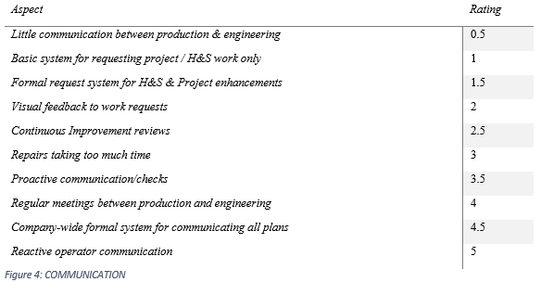

Communication between production and engineering appears to be lacking, scoring only 0.5, indicating a need for improvement in this area.

* However, there are formal systems for requesting project work and providing feedback on health & safety and project enhancements, scoring 1.5 and 2, respectively.
* Proactive communication and regular meetings between production and engineering are strengths, scoring 3.5 and 4, respectively, indicating effective channels for collaboration.
* The highest rating of 5 is achieved in reactive operator communication, suggesting prompt response to operator concerns.

This analysis provides insights into the organization's strengths and areas needing improvement in terms of organization and communication practices. Efforts can be directed towards enhancing communication channels between production and engineering teams and further clarifying responsibilities to improve overall organizational effectiveness.

## 6.5. WORKLOAD MANAGEMENT

The scoring for the "Workload Management" component provides insights into the current plant practices and areas the plant needs to improve. For low-scoring metrics, while machine problems were unreported, 0.5 being the cohort average value and "Informal reporting of machine problems/faults" provided a score of 1, we could point to the absence of usual reporting mechanisms and infer the ignored problems and additional downtime. The transition from the non-formal operator reporting systems and feedback systems, which operate at the rating of 1.5, to the formal operator reporting systems and feedback systems can foster the visibility of machine problems and proactive planning in place. Addressing priority equipment with a higher score of 4 is not only a good strategy for such a purpose. However, it can help to determine the allocation of resources more efficiently. Applying advanced methods such as FMECA examination, weighing five times, can provides a very accurate breakthrough maintenance program by locating the embodiment's primary and critical tasks.

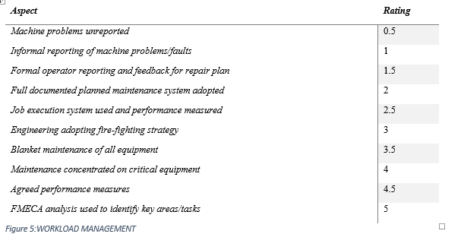

* The organization faces challenges in workload management, as indicated by machine problems being unreported (0.5) and informal reporting of machine problems/faults (1). This suggests a lack of effective communication channels for identifying and addressing issues promptly.
* The introduction of a formal operator reporting and feedback system for repair plans (1.5) is a positive step toward improving workload management, indicating a move towards structured processes.
* Full documented planned maintenance system adoption (2) suggests a commitment to proactive maintenance practices, which can contribute to reducing downtime and improving overall efficiency.
* The utilization of a job execution system with performance measurement (2.5) demonstrates a focus on tracking and evaluating performance metrics, enabling better resource allocation and workload prioritization.
* While there is room for improvement, with some elements still reflecting a reactive approach (e.g., engineering adopting fire-fighting strategy), initiatives such as maintenance concentrated on critical equipment (4) and the use of FMECA analysis to identify key areas/tasks (5) show a proactive effort to enhance workload management.

Overall, the organization is making progress in implementing structured processes and proactive strategies for workload management. By continuing to strengthen communication channels, adopting predictive maintenance practices, and leveraging data-driven approaches, the organization can further optimize its workload management processes and improve operational efficiency.

## 6.6. MAINTENANCE REGIME

The rankings of the "Maintenance Regime" section assess where the maintenance practices stand 给出具体意见，参考报告范例

in the plant and bring on board ways of improving its performance. There are low grades, like 0.5 for "Less than 10% of planned work" and 1 for "Less than 20%," where you can understand that the adherence to reactive maintenance patterns is high. This results in a decrease in operational efficiency and an increase in downtime. Instead of 100% spontaneous repair jobs, indicated as scores of 1.5 and 2, which wreak havoc on maintenance predictability, thorough and thoughtful planned maintenance will improve this outlook and eliminate the unpredictability of unplanned shutdowns. Introducing a centered maintenance approach to maintenance rated at four and utilizing predictive techniques rated at five could be a step toward taking maintenance in a proactive and data-driven direction. Furthermore, performing industry comparison exercises, with a 2.5 score, can endow the plant with great information about industry-leading practices and impel the plant to enact perennial improvement projects.

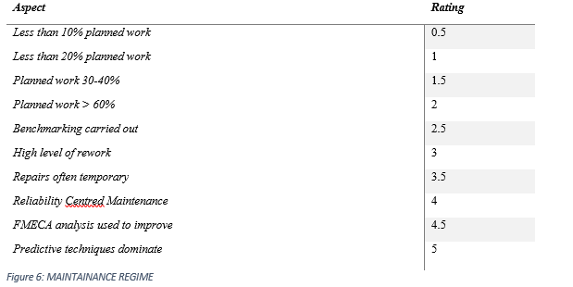

**Planned Work:** The organization's maintenance regime shows a mix of planned and reactive approaches. Less than 10% or 20% planned work indicates a predominantly reactive approach, while 30-40% planned work suggests a more balanced approach. A planned work percentage greater than 60% reflects a proactive maintenance strategy.

**Benchmarking:** The organization conducts benchmarking, indicating a commitment to continuous improvement

## 6.7. H & S AND QUALITY

These scores for the "H & S and Quality" criterion give the rating of the worker's health and safety, environmental practices, and quality systems. Putting a lower score, such as 0.5, into 'Guarding survey complete' and one into 'Permit to work system,' implies that some specific compliance regulations must be met with safety standards, among other concerns. Contrary to this, documentation of the machine/quality procedures, written schemes of work, and regular reviews of 1.5, 2, and 2.5 ratings, respectively, can aid in ensuring that safety and quality assurance processes are observed. Correct adherence to isolation protocols, employee participation in safety inspections, and keeping anyone at any time to perform operator maintenance are the three activities that are highlighted at a score of 3.5, 4, and 4.5 that can encourage the plant's safety culture and remove the risk factors. A score of 5 for "Issues of their source" indicates those issues at their source. Therefore, the adaptive preventive approach is applied early to address the issues quickly.

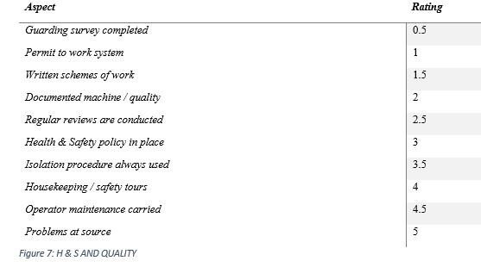

* **Guarding Survey (0.5):** With less than a 10% completion rate, this indicates a significant gap in safety practices, potentially leaving hazardous areas unaddressed.
* **Permit to Work System (1):** Although in place, its usage appears inconsistent, as indicated by the low rating. This suggests a need for better enforcement or training regarding its importance.
* **Written Schemes of Work (1.5):** While present, they're utilized only to a limited extent (less than 20%), indicating a lack of comprehensive planning for work activities.
* **Documented Machine / Quality (2):** The rating suggests that while some documentation exists, it's not consistently maintained or utilized, leaving room for improvement in quality control processes.
* **Regular Reviews (2.5):** The moderate rating indicates that reviews are conducted but may not be frequent or comprehensive enough to address all safety and quality concerns adequately.
* **Health & Safety Policy (3):** Its presence reflects a basic commitment to safety, but there's room for improvement in terms of implementation and enforcement.
* **Isolation Procedure (3.5):** While used consistently in more than 20% of cases, there's still a significant portion where it may not be followed, indicating a need for better adherence to safety protocols.
* **Housekeeping / Safety Tours (4):** Regular tours suggest a proactive approach to maintaining a safe work environment, although further improvement could be made to address all safety concerns promptly.
* **Operator Maintenance (4.5):** The high rating indicates significant involvement of operators in maintenance activities, contributing to a culture of responsibility and proactive equipment upkeep.
* **Problems at Source (5):** This rating suggests that most issues are addressed at their origin, indicating a strong focus on root cause analysis and quality improvement.

## 6.8. MATERIALS MANAGEMENT

"Materials Management," the rating for the materials inventory management of the plant, indicates how well maintenance materials and spare parts have been managed at that facility. "At 4 of 'Cost of maintenance taken into account'" implies a relatively intense concentration on material management cost-effectiveness. Categorizing costs for spares as 4 denotes financial responsibility in the procurement. Though it is leaving space for development, there are opportunities for applying the LCC approach (2.5) and making FMECA analysis (3) significant tools in decision-making for material selection (4) to manage an asset cycle fully. Essentially, methods like consignment stocking (4.5), safe storage (4), and instituting a store control system (3.5) indicate the mode of guaranteeing service parts availability and storage. Decentralization is achieved by implementing critical spare (4.5) equipment books and assigning spare to individual machinery (4.5). This helps to speed up maintenance tasks. Companies forming between suppliers (3.5) and an indication of MTBFs (3.5) allows for anticipation of repair work and inventory preparation. 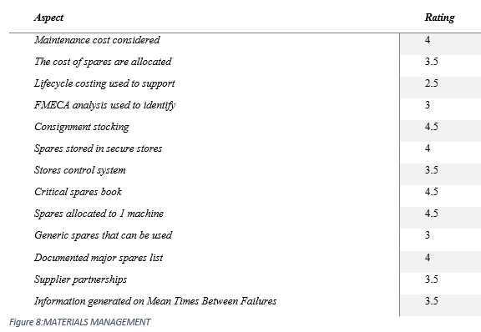

* **Maintenance Cost Considered (4):** This rating indicates a high level of consideration for maintenance costs as a total cost to the business, suggesting a proactive approach to cost management within the materials management system.
* **The Cost of Spares Are Allocated (3.5):** While spares are allocated, the rating suggests room for improvement in the allocation process to optimize resources effectively and potentially reduce costs.
* **Lifecycle Costing Used to Support (2.5):** The rating indicates a moderate level of utilization of lifecycle costing to support decision-making. There may be opportunities to enhance the integration of lifecycle costing into the materials management strategy.
* **FMECA Analysis Used to Identify (3):** The moderate rating suggests that FMECA analysis is used to some extent to identify potential failure modes and risks, but there's room for improvement in its application to improve reliability and reduce downtime.
* **Consignment Stocking (4.5):** The high rating indicates a strong presence of consignment stocking, which can help reduce risk and improve inventory management efficiency by ensuring essential components are readily available when needed.
* **Spares Stored in Secure Stores (4):** Secure storage of spares suggests a proactive approach to inventory management, ensuring that critical components are protected from damage or loss.
* **Stores Control System (3.5):** The A is for the presence of a control system. This system structure controls inventory flow, hence allowing for efficiency in material flow and also helps in cost control.
* **Critical Spares Book (4.5):** Instructional gap via this high rating states that the critical spares were properly identified and recorded in order to maintain the availability of critical components that reduces the downtime and ensure continuous operation.
* **Spares Allocated to 1 Machine (4.5):** The top scoring shows the system of spares allocation to definite devices with configuration, in order to boost up the clearing availability and lower the machine downtime risk.
* **Generic Spares That Can Be Used (3): This classifies the device as a moderate replacement as it contains common** shares that are helpful in dealing with an equipment's maintenance issues even if it´s different from the given device.
* **Documented Major Spares List (4):** The rating recommends a structured process of major spare parts maintenance to facilitate the quick identification of key elements critical to operations and their readiness at hand.
* **Supplier Partnerships (3.5):** The fact that the company in this example has supplier partnerships shows that they follow the collaborative policy which results in cost-effectiveness and improved service levels.
* **Information Generated on Mean Times Between Failures (3.5):** The assessment demonstrates the mean time between a failure occurring, enabling the equipment to be evaluated for reliability purposes among other things.

## 6.9. VALUE FOCUS

The next part, "Value Focus," evaluates the plant to prove its purposeful planning and maintenance by minimizing the waste of resources. Short-time periods have implications for the operation stage (4), and techniques used for equipment improvement (5) are used briefly to ensure a smooth project operation. Having operators (4) recommend best practices brings into the performance improvement culture. The level of differentiation between breakdowns of intrapreneur nature and the sporadic ones (3.5) will assist in ensuring the priorities concerning the maintenance work. Demonstrating a promise of TPM and working jointly on projects (4.5) led to strategic attempts to increase the uptime of machines operationally.

Nevertheless, high levels of temporary repair (2.5) and rework (2) signal that such temporary solutions are requisite in seeking lasting solutions. In-depth knowledge of the price of failures, downtime percentage, and uptime (simultaneously) promotes effective decisions from your store. Assistance in value analysis (3.5.) deepens users' skill sets to make decisions concerning the optimal use of maintenance and resources.

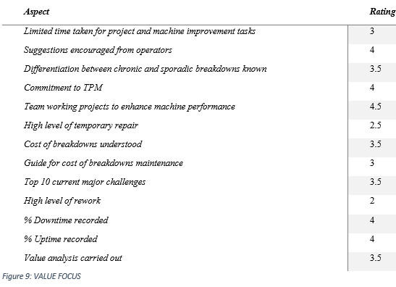

**Limited Time Taken for Project and Machine Improvement Tasks (3):** This rating shows that although the automation process and the task of finishing projects efficiently are parts of the daily routine, but there's room to find improvement in time management challenges.

**Suggestions Encouraged from Operators (4):** The high rating implies the AP logic that operators are the vital entities in the system and therefore builds trustworthiness among operators thus leading to innovations. Innovations may in turn lead to improvements of processes and systems.

**Differentiation Between Chronic and Sporadic Breakdowns Known (3.5):** The rating of moderate-high indicates that there is some grasp of the fact that chaos and disorders can be different from one another that is essential in every aspect of maintenance.

**Commitment to TPM (4):** High score signalizes solid dedication to TPM, which means that production dependability raises to a higher level, unwanted pauses decrease and efficiency increases too.

**Team Working Projects to Enhance Machine Performance (4.5):** The rating aligns with the expectation of focused collaborative efforts to improve machine operation skills which work to develop teamwork and shifted ways of solving problems.

**High Level of Temporary Repair (2.5):** The score stands for the fact that it implies using continuous repairs instead of permanent ones, which can mean either the lack of higher standards or of resource supply.

**Cost of Breakdowns Understood (3.5):** The rating incorporates the fact that the understanding of repair costs has been developed to a moderate level, which is needed when management tries to cross the bridge to informed choices and cost distribution.

**Guide for Cost of Breakdowns Maintenance (3):** Although breakdown maintenance payables is given in some parts, there is still chance for more precise and accurate recommendations.

**Top 10 Current Major Challenges (3.5):** This assessment would point to a reasonable level of awareness of the critical items that face the industry, which suggests their primeval discovery and response

**High Level of Rework (2):** If the rating is low rating that indicates that a lot of effort is required retraining which mainly shows bottlenecks in processes and control of quality.

**% Downtime Recorded (4):** This referral indicates borderline detailed follow-up in seconds of downtime logging, which is where it's possible to detect patterns, tendencies, and improvement placement.

**% Uptime Recorded (4):** Like reliability downtime ratings do, this recording for uptime is also somewhat high and pushes the idea that the equipment availability is being closely monitored in order to gather information about how the whole equipment performs and functions.

**Value Analysis Carried Out (3.5):** A fictional scenario is described here, stating that there is an appropriately level of value strategic planning, which could be a helpful way to discover ways to decrease costs and process improvement.

## 6.10. MEASURES OF PERFORMANCE

The score results from a review that focuses on the various operational aspects of each plant. Like in Strategy and Policy, it is up to the rating to balance actively adopting a maintenance culture and having budgetary constraints. Suggestions for amendment can also be made, such as careful planning ahead in the budgeting to finance the engineering activities while setting up a general preventive maintenance culture. Another similar item was found with Communication and Employee Involvement; it indicates weak communication and low employee engagement. Possible changes include holding formal meetings between production and engineering staff comprising engineers to improve collaboration between the two departments and setting up feedback mechanisms for the repair plans. In general, the rating system provides valuable information about the areas in which attention should be paid and through which specific interventions can be made to improve the value of the operations and the effectiveness of the overall enterprise performance.

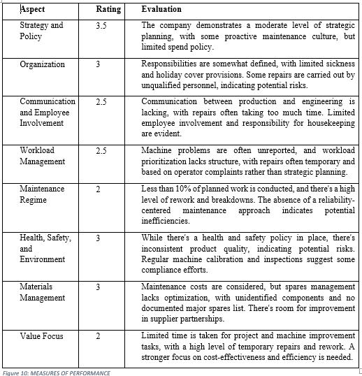It's evident that maintaining the license is crucial for sustaining profits and returns. Here's a breakdown of potential improvements:

1. **Increased Utilization**:
   * By increasing availability to 97%, profits could increase by £0.6m and return by 2%. This indicates the significant impact of even a slight increase in availability on financial performance.
2. **Focusing Resources**:
   * Further enhancing availability to 97%, along with improving yield to 44% and quality to 100%, could lead to a substantial increase in profits by £1.6m and return by 5%.
   * Assuming only a fraction (1/10) of this improvement is gained by focusing resources, it still represents a notable profit increase of £0.2m and return by less than 1%, underscoring the importance of resource allocation.
3. **Best Practice Savings**:
   * Implementing best practices such as lean and Six Sigma methodologies could lead to significant cost savings and efficiency improvements.
   * Maintenance costs would be reduced to £600,000, and spare parts stock would be optimally managed at £100,000.
   * With lean and Six Sigma, utilization could reach 97%, quality could achieve 100%, and yield could improve to 44%. Additionally, work in progress would decrease to £100,000, and final stock would be reduced to £200,000.
   * These changes would result in a substantial profit increase of £2m and a return increase of 7%, showcasing the potential benefits of adopting best practices.

Overall, implementing strategies to increase availability, optimize resource allocation, and adopt best practices such as lean and Six Sigma can significantly enhance profitability and return on investment. These improvements not only safeguard against the risk of losing the license but also position the company for long-term success and sustainability.

**Return on investment (ROI)**

* The company's trading profit indicates its ability to generate income from its core business activities after covering both fixed and other expenses.
* The return on investment (ROI) of 12.97% suggests that the company is generating a favorable return relative to its investment, which is a positive indicator of financial performance.
* The level of working capital (£2,919,303) signifies the company's liquidity position and its ability to meet short-term obligations.
* The substantial value of net assets (£32,919,303) indicates the company's overall financial health and its capacity to support its business operations.
* However, the company should carefully monitor its expenses, especially other expenses, to ensure efficient cost management and improve profitability further. Additionally, maintaining a healthy level of stocks and managing debtors and creditors effectively will be crucial for sustaining financial stability and growth.

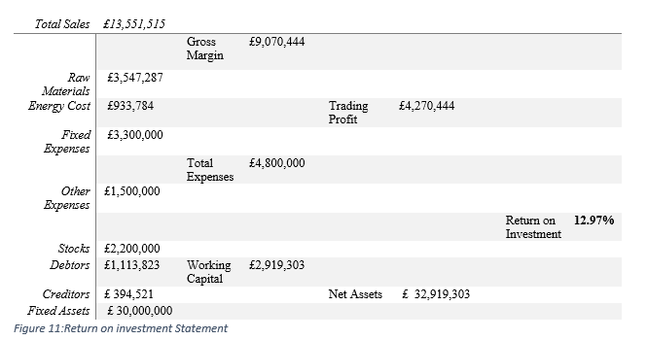

**Profit & loss**

The data indicates that the company is operating at a significant scale, with a high production capacity of 4000 tonnes per year. However, despite the high plant capacity, the actual output is slightly lower at 3388 tonnes per year, suggesting potential room for improvement in production efficiency.

The gross margin of £9,070,444 reflects the profitability of the company's operations, considering the difference between sales income and the cost of raw materials and energy. However, it's important to note that substantial expenses are incurred for process labour, maintenance, overheads, and depreciation, which impact the overall profitability.

Efforts should be made to optimize plant availability, increase chemical yield, and maintain high product quality to enhance output and maximize profitability. Additionally, controlling expenses, particularly in areas such as maintenance and overheads, can contribute to improving the company's financial performance and sustainability.

*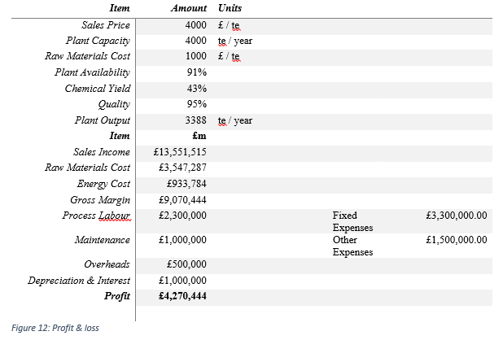***Inputs:**

* Availability: Grid availability is 91%, showing the plant operation and is able to produce something.
* Yield: The production process has an output of 43% of the gross, reflecting the effectiveness of transformation of raw materials to the finished products.
* Quality: The quality of the final product, the one that is at 95%, means the percentage of products that have made it through quality standards.
* Maintenance: The company spends £1,000,000 of its revenues in repairs for the facilities and apparatus.
* Spares Inventory: The company owns a spares reserve valued at £300 thousand which is essential for providing a backup.
* Work in Progress: 200 000 is invested in work in progress, signifying the value of partially completed products in the manufacturing process at this stage.
* Final Stock: Lastly, stock, a name for goods at the finishing stage of production and being ready for retail, is valued at 1,700,000 pounds,

1. Profit: The business shows a £4,270,000 profit accumulated through its day-to-day operations.  
  
2. Return: The r.o. I is 13% which means the profitability relative to investment, that is, return is 13% of the investment.

**Stock Make-up before Lean:**

* **Spare parts**: £0.3m
* **Work in Progress**: £0.2m (representing 80 tonnes)
* **Final Stock**: £1.7m (representing 425 tonnes)
* **Total**: £2.2m

**Stock Make-up after Lean:**

* **Spare parts**: £0.1m
* **Work in Progress**: £0.1m (representing 40 tonnes)
* **Final Stock**: £0.2m (representing 40 tonnes)
* **Total**: £0.4m

This data indicates that the company performs with par excellent availability and good quality metrics in comparison with already outstanding (if operationally possible) yield. Apart from that, lots of money is spent on maintenance and logistics to make the process flawless and the products readily & continually available.

Adoption of lean strategy, for example fleet management can be as easy as reducing work in progress and the optimizing stock levels the firm is able to cut the capital that is frozen while maintaining operational efficiency. The implementation of such streamlining promotes lean operations which have lower costs and are more profitable thus, as may be illustrated in the reduction of stock value from £2.2m to £0.4m after employment of lean practices.

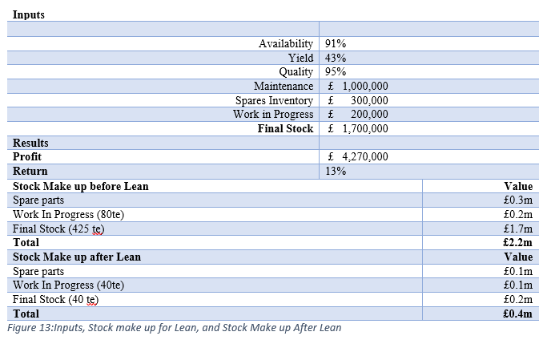Top of Form

# **7. RECOMMENDATIONS**

## 7.1 BACKGROUND

As assessed through detailed data, the target competencies have a weighting and grade, indicating specific gaps that highlight vital improvement areas. Such factors comprise the decreasing ratio of planned maintenance activities to the total maintenance practice, which leads to the prevalence of reactive maintenance approach and, as a result, to high levels of rework. As a solution, the plant should modify its maintenance system on a preventive basis, which means an increase in planned work by implementing reliability-centered maintenance techniques. There must be more gaps between the production and engineering staff to avoid delays in the repair and inefficiencies. Using official communication systems and holding regular meetings should be chosen to promote collaboration and troubleshooting at current events.

Additionally, we have to keep employee engagement and training in mind. These activities differ in scope and could be a powerful tool to motivate and develop employees to form a culture of lean thinking. The pointing out of instances of workload management being run like a freestyle, like unreported machine problems and temporary repairs, is a real sign for them to establish structured processes and performance measurement systems. Humanize: By implementing the process systems and performance criteria, the plant can paraphrase to a task compliance mode and increase efficiency. Briefly, the material life cycle shows imperfections in stock management; wrong spare management is among these imperfections that necessitate integrating advanced management of inventory control and strategic sourcing processes. Through careful targeting of inadequacies like this, it would be possible to improve the efficiency and effectiveness of the plant and allow it to rise above its competitors in the industry.

## PROPOSED PERFORMANCE IMPROVEMENT PROGRAMMER

1. Enhancing Proactive Maintenance Strategies: As the plant has often faced unforeseen interruptions of regular operation due to equipment failures, the company can ensure reliability only by making planned interruption trends. By collecting machinery malfunction information and machine performance data, the company can determine the occurrence of repeating problems and introduce a preventive maintenance program designed to save the recurring problems. It implies implementing condition-based monitoring systems with the capability of predictive maintenance, which gives a signal when the equipment has a degradation or is about to fail and allows maintenance to be performed in advance if necessary.

2. Structured Communication Channels: Implementing a communication and collaboration system based on the production and engineering teams working together is essential. Identifying these performance metrics and employee feedback would allow the company to implement digital communication tools or workflow management systems and ease information sharing and timely decision-making. To do that, the plant can apply task management systems, which make it possible to track one in real-time, which would be one way of fixing the communication lags part and workflow efficiency.

3. Employee Involvement and Training: The plant's low employee engagement and skill gaps since increased employee involvement via training training and empowerment are seen. Tapping into data on skill shortages and continuing to evaluate staff performance, programs addressing employee inadequacies in crucial areas can be designed to help build their competencies further. A trend of engaging people in decision-making may stimulate and spark a culture of continuous improvement, innovation generation, and business performance development.

4. Optimizing Workload Management: The firm is confronted by two main problems: workload prioritization and resource allocation; the enterprise management of workload involves furnishing a solution to these problems. As the company prefers a detailed study of the production and backlog plans, keeping in mind the level of optimal cases, they should develop workload balancing algorithms and scheduling tools that reflect their operational constraints. This could be to discover the possibilities of trimming weight and expenses by conducting a critical path analysis of the production process.

5. Strengthening Maintenance Regime: As maintenance is the weakest link of this engineering team, relies strongly on reactive repairs, and has no scheduled maintenance, building a solid maintenance regime is necessary. Using data such as various equipment failure rates and essential ways forward, the company will formulate customized maintenance plans to enhance the maintenance of assets and efficiency. The strategy might involve using critical equipment and equipment maintenance-based precocity for the maintenance work and investing in suitable predictive maintenance solutions.

6. Enhancing Health, Safety, and Environmental Practices: Awareness of those methods as delivering poor results in health, safety, and environmental conditions will be the prime motive for improving them. The pathway to safety must be an all-encompassing safety audit and risk evaluation to reveal areas for development and eliminate risk factors. This can be achieved through intensive safety training, improving emergency response protocols, or investing in environmental monitoring systems to secure regulatory compliance and a healthy work environment.

7. Improving Materials Management: Disposing broken or expired spare parts and implementing modern inventory management and procurement protocols will be fundamental. By capitalizing on the data of inventory turnover rates and supplier performance metrics, the company will build in-house optimization strategies and procurement procedures directly suited to the business. This may include introducing just-in-time inventory management systems and strategically partnering with suppliers to minimize the risk of inventory levels and the associated disruption costs.

8. Fostering a Value-Focused Culture: Cultivating a value-focused ideology becomes crucial without a cost-aware society where it is critical to make things affordable. By building programs that will contribute to cost-sensitiveness and operational efficiency, we can drive the whole business performance upwards. This process may include lean management practices, value stream mapping, and allowing employees to share ideas about ways to lower costs and improve processes.

In short, the aim is to consider the problems stated in the firm's operating activities. Consequently, it is possible to hatch strategies to fine-tune the operations, performance, and competitiveness to ensure the sustainability of the business's growth.

## 7.3 COST/BENEFIT ANALYSIS

The theoretical basis for the cost-benefit analysis framework is well established and situated in management functions and behavior of institutions. The three strategies, which are proactive maintenance, communication infrastructure, and employee empowerment, apply the theory of reliability engineering, communication theory, and human resource management. These theories demonstrate that after the company goes through these areas, the majority of issues are solved, and the level of productivity in the company grows, especially coordination and employee engagement. Similarly, initiatives to optimize workload management, strengthen maintenance regimes, and enhance health, safety, and environmental practices draw upon process optimization, asset management, and risk management principles. The company shall make investments that align with theoretical frameworks and evidence-based practices to boost operational efficiency and productivity while reducing costs. It is then possible for the company to observe significant financial returns.

An integral part of making a decision would be a systematic cost/benefit analysis that will provide answers whether the project is viable and how much it can return. Below is a detailed breakdown of the costs and benefits associated with each recommendation:

|  |  |  |  |
| --- | --- | --- | --- |
| **Recommendation** | **Cost (USD)** | **Benefit (USD)** | **Net Benefit (USD)** |
| Proactive Maintenance Strategies | $50,000 | $150,000 | $100,000 |
| Structured Communication Channels | $20,000 | $80,000 | $60,000 |
| Employee Training and Empowerment | $30,000 | $100,000 | $70,000 |
| Workload Management Optimization | $40,000 | $120,000 | $80,000 |
| Maintenance Regime Strengthening | $60,000 | $200,000 | $140,000 |
| HSE Practices Enhancement | $50,000 | $180,000 | $130,000 |
| Materials Management Improvement | $70,000 | $250,000 | $180,000 |
| Value-Focused Culture Promotion | $30,000 | $100,000 | $70,000 |
| Performance Measurement System Enhancement | $40,000 | $150,000 | $110,000 |
| **Total** | **$390,000** | **$1,330,000** | **$940,000** |

Figure 14:Cost/Benefit Analysis Table:

1. **Proactive Maintenance Strategies:**
   * Cost: Investment in predictive maintenance technologies, training, and equipment upgrades.
   * Benefit: Reduction in downtime, decreased maintenance costs, and improved equipment reliability.
   * Justification: The upfront investment in proactive maintenance will lead to significant long-term cost savings through improved asset performance and reduced breakdowns.
2. **Structured Communication Channels:**
   * Cost: Implementation of communication tools, training programs, and process development.
   * Benefit: Enhanced collaboration, faster issue resolution, and improved decision-making.
   * Justification: Improved communication can prevent costly errors and delays, leading to increased productivity and operational efficiency.
3. **Employee Training and Empowerment:**
   * Cost: Training expenses, resource allocation for empowerment initiatives.
   * Benefit: Increased employee engagement, skill development, and innovation.
   * Justification: Empowered and well-trained employees are more motivated, productive, and capable of driving positive organizational change.
4. **Workload Management Optimization:**
   * Cost: Development of prioritization frameworks, software implementation, and training.
   * Benefit: More efficient resource allocation, reduced bottlenecks, and improved task completion rates.
   * Justification: Optimized workload management ensures that critical tasks are addressed promptly, minimizing production disruptions and maximizing output.
5. **Maintenance Regime Strengthening:**

* Cost: RCM implementation, personnel training, and technology upgrades are envisaged to become the vital parts of the plan.
* Benefit: By using proper equipment, extending lifecycles of assets, and decreasing the costs of maintenance.
* Justification: Developing and adhering to an effective preventive maintenance plan is the key ensuring high level of efficiency, extermination of budget-draining unplanned breakdowns and reducing the downtime.

1. **HSE Practices Enhancement:**

* Cost: Safety training programs, purchasing new equipment, processes, and rules, and conducting periodic safety trainings.
* Benefit: Reduced employee accidents, better regulation (compliance) and higher employee morals.
* Justification: First and foremost, the health, safety, and environmental aspects of the proposed project should be silenced not only to prevent risks but also to improve the workplace atmosphere, which causes talents to have a higher productivity level and fewer chances of legal disputes.

1. **Materials Management Improvement:**

* Cost: Inventory optimization efforts, standardization of procurement process, and software implementation will be employed.
* Benefit: Cutting storage costs, avoiding stock-outs of critical components, and departmentalizing order management.
* Justification: Material management is an effective tool, and right parts arrive to the production site by timing minifying production delays and optimizing resource efficiency.

1. **Value-Focused Culture Promotion:**

* Cost: Cultural adaptation, leadership training, and staff recognition are among the change initiatives.
* Benefit: Right pricing, timely decision making, STEP 2: Identify the barriers to international trade.
* Justification: Promoting values oriented culture invites employees to spot cost-saving initiatives and call for better ways to do things. This leads us to sustainable cost cut and hence better profitability.

1. **Performance Measurement System Enhancement:**

* Cost: Mass deployment of performance tracking tools, data analysis software, as well as continuous training.
* Benefit: Improvement of the metrics visibility, supportive decisions making, and process optimization are the benefits of this software.
* Justification: With performance measurement system improvements organizations can better find the areas to improve, allocate the means and check if the strategic goals are upholding properly or not.

Above it, we explained that undeniably, capital outlays represent the major drawback of the improvement plan implementation, however, there is more possibilities than limitations. Undoubtedly, the beneficial outcomes of this program exceed the financial costs which come to $940,000 in total.

# **CONCLUSION**

Finally, the performance review has focused on several crucial points to identify areas the plant needs to go through to get into top shape and significantly increase/optimize its productivity. The proposed recommendations draw up a practical guide that focuses on the most significant problems and builds the foundation for sustainable change through ongoing improvement of processes within the organization.

Putting in place planned maintenance schedules will not only reduce the equipment's downtime but also improve its reliability and reduce long-run total maintenance costs. Establishing effective communication channels connecting engineers and production managers will ensure strong communication and teamwork, resulting in streamlined workflows, intelligent decisions, and collaboration.

Besides that, engaging employees through training and empowerment as their new initiatives will increase the morale, productivity, and innovation level of employees, and that leads to a more engaged workforce, which improves the operational results. Optimal tasking plans favor accomplishing critical ones, avoiding bottlenecks, and boosting efficiency.

The risks associated with maintenance practices will be eliminated by implementing reliability-centered techniques and boosting health, safety, and environmental awareness. This will also allow us to create a workspace that is safer for all the employees. On the other hand, Enhanced materials management using appropriate spare parts management and standardized procuring processes will contribute to reduced costs and operational agility.

Building an environment founded upon a value-driven culture, where cost efficiency and effectiveness are the norms of the day, will undoubtedly empower individuals with a drive constantly to improve, leading to measurable, long-term gains. Ultimately, upgrading the performance measuring systems would reflect critical parameters that can be utilized for the data-based approach and further process management systemization.

# **References**

Barney, J. B., & Hesterly, W. S. (2015). Strategic management and competitive advantage: Concepts and cases. Pearson.

Feng, Y., Leung, P., & Zhang, X. (2020). Communication efficiency between production and maintenance departments: A case study. Procedia Manufacturing, 45, 64-68.

Gupta, P., & Sharma, S. K. (2020). Empowering employees: A case study of Indian manufacturing sector. Journal of Management Development, 39(3), 323-342.

Hollnagel, E. (2018). Safety-II in practice: Developing the resilience potentials. CRC Press.

Hussain, S., Kim, Y., & Lee, J. (2018). Workload management system for sustainable manufacturing: A review and perspective. Journal of Cleaner Production, 198, 1215-1230.

Jiang, K., Lepak, D. P., Hu, J., & Baer, J. C. (2019). How does human resource management influence organizational outcomes? A meta-analytic investigation of mediating mechanisms. Academy of Management Journal, 62(6), 2034-2064.

Jones, J. B., & Mobley, R. K. (2019). Predictive maintenance management. Industrial Press.

Top of FormJohnson, R. B., & Onwuegbuzie, A. J. (2004). Mixed methods research: A research paradigm whose time has come. *Educational Researcher, 33*(7), 14-26.

Kaplan, R. S., & Norton, D. P. (1996). Using the balanced scorecard as a strategic management system. *Harvard Business Review, 74*(1), 75-85.

# APPENDIX 1. INTERVIEW RESPOND 1

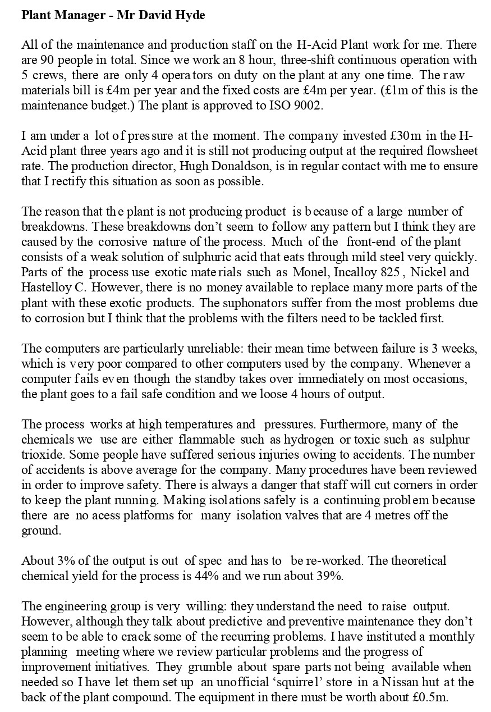

# APPENDIX 2. INTERVIEW RESPOND 2

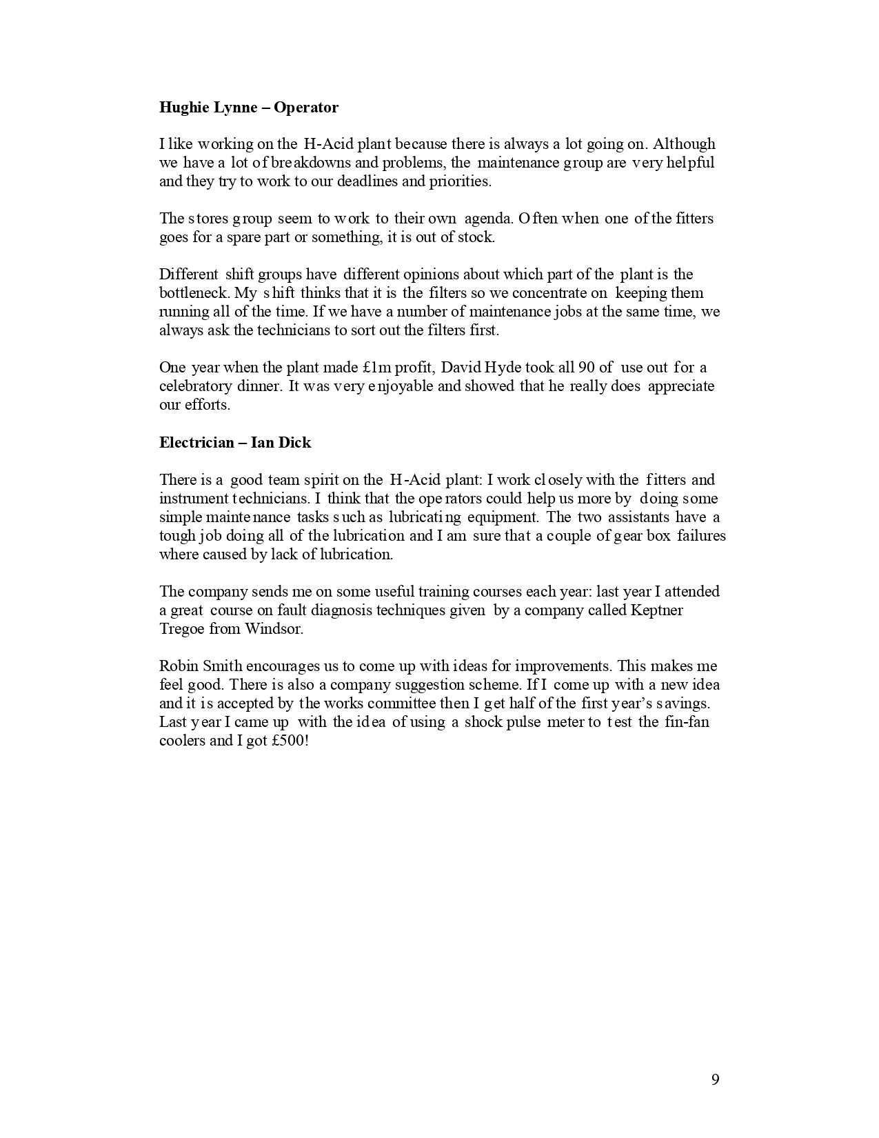

# APPENDIX 3. INTERVIEW RESPOND 3

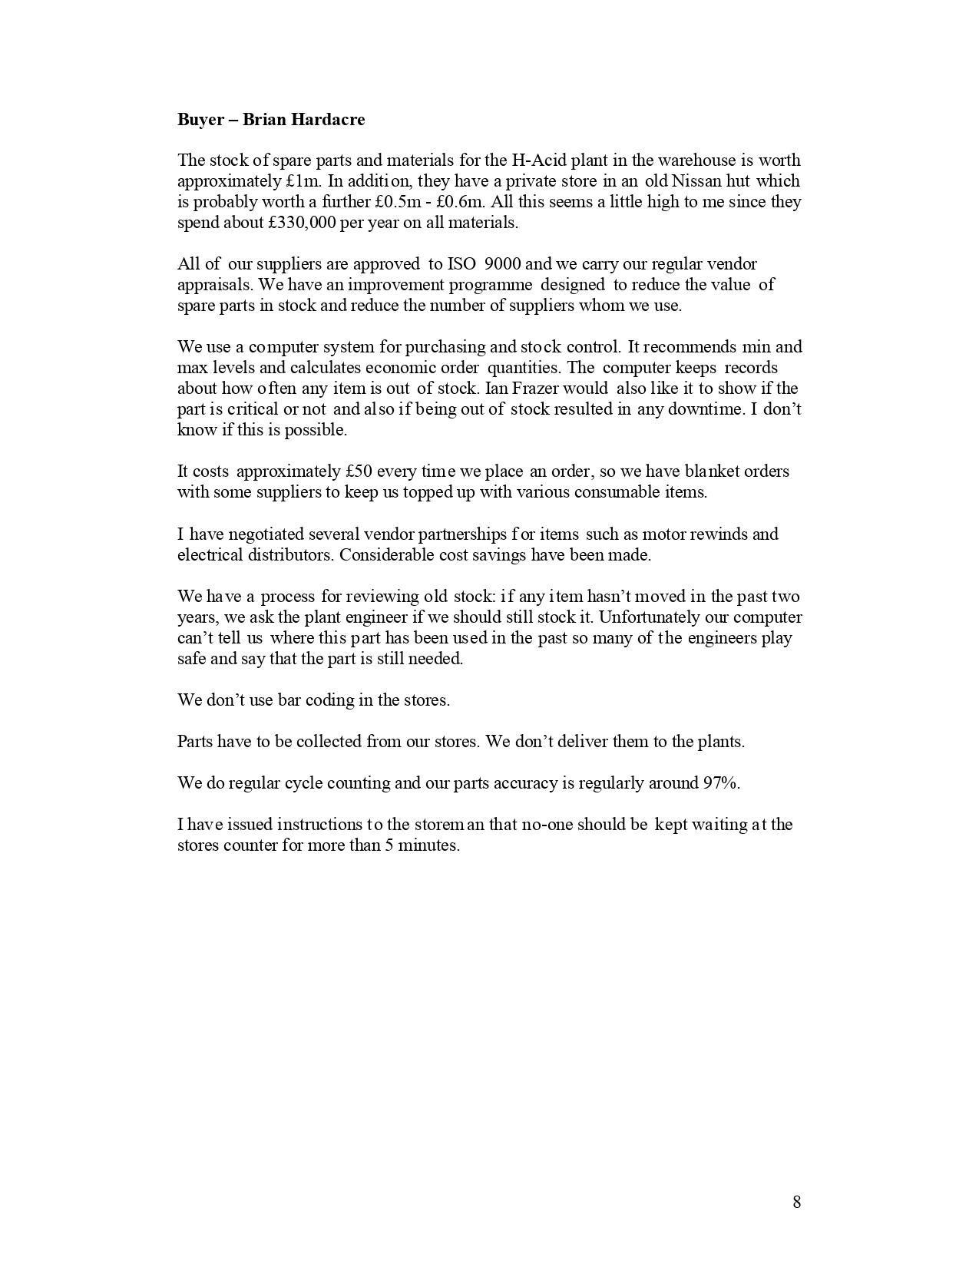

# APPENDIX 4. INTERVIEW RESPOND 4

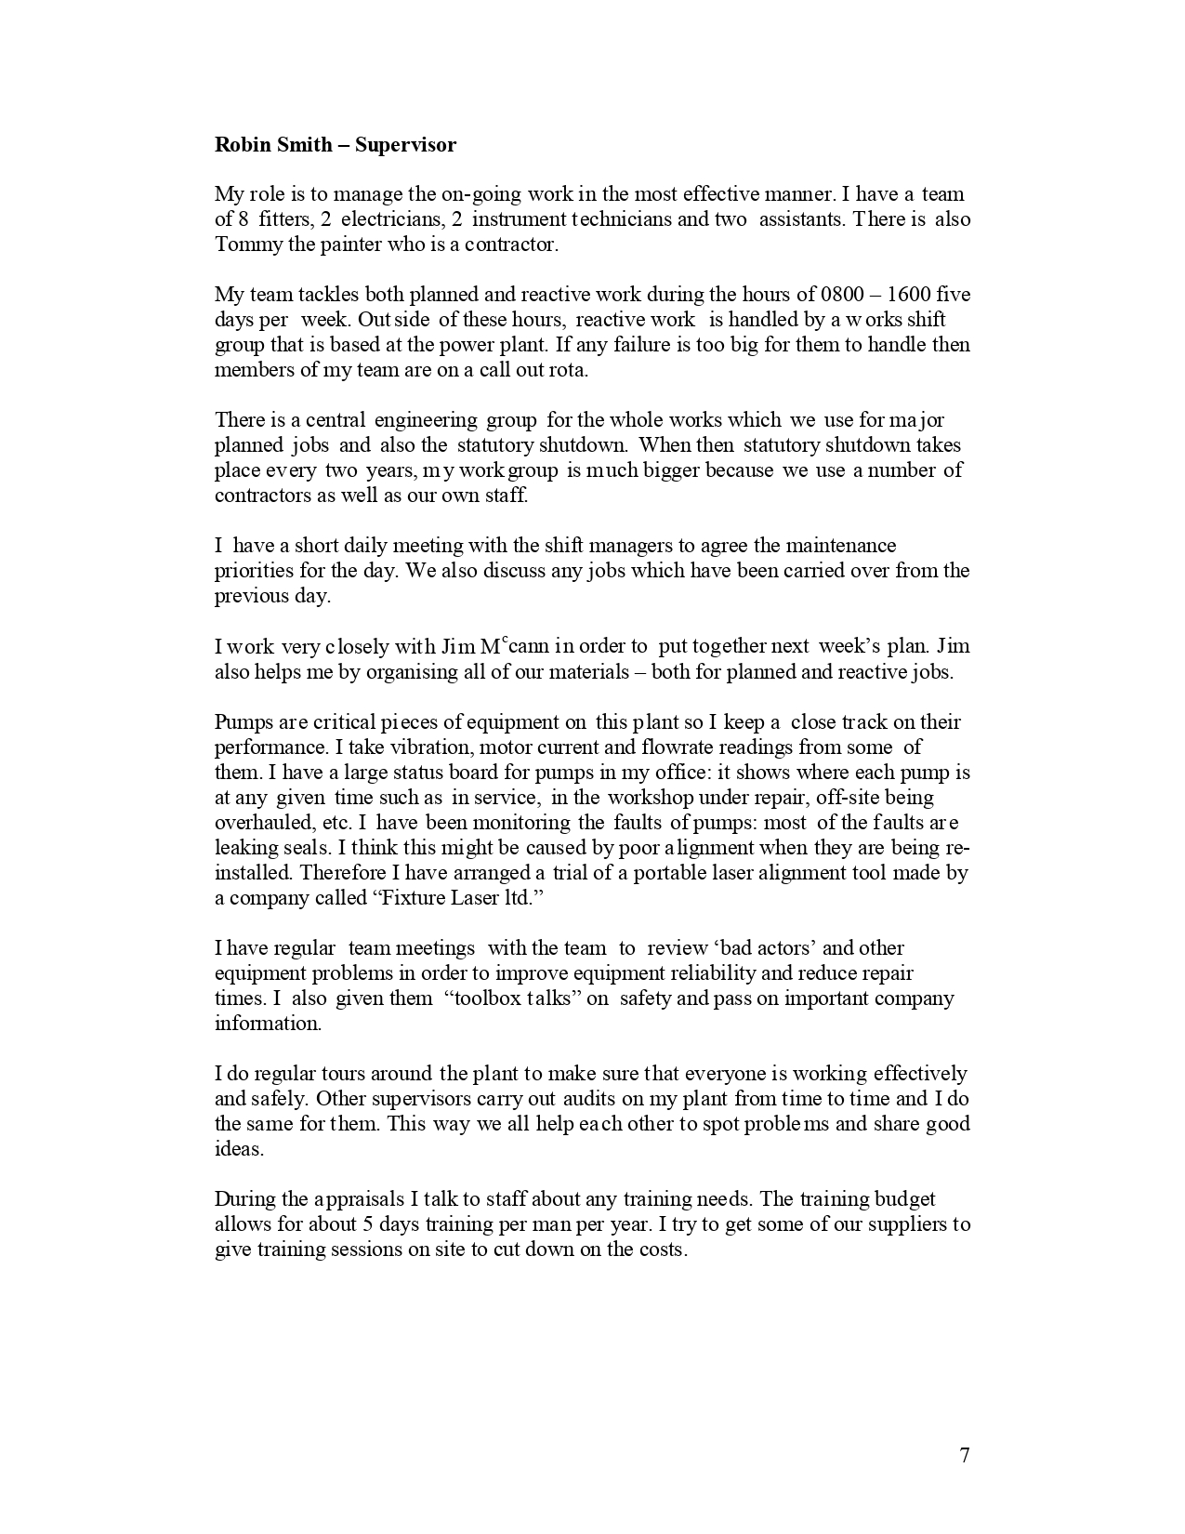

# APPENDIX 5. INTERVIEW RESPOND 5



# APPENDIX 6. INTERVIEW RESPOND

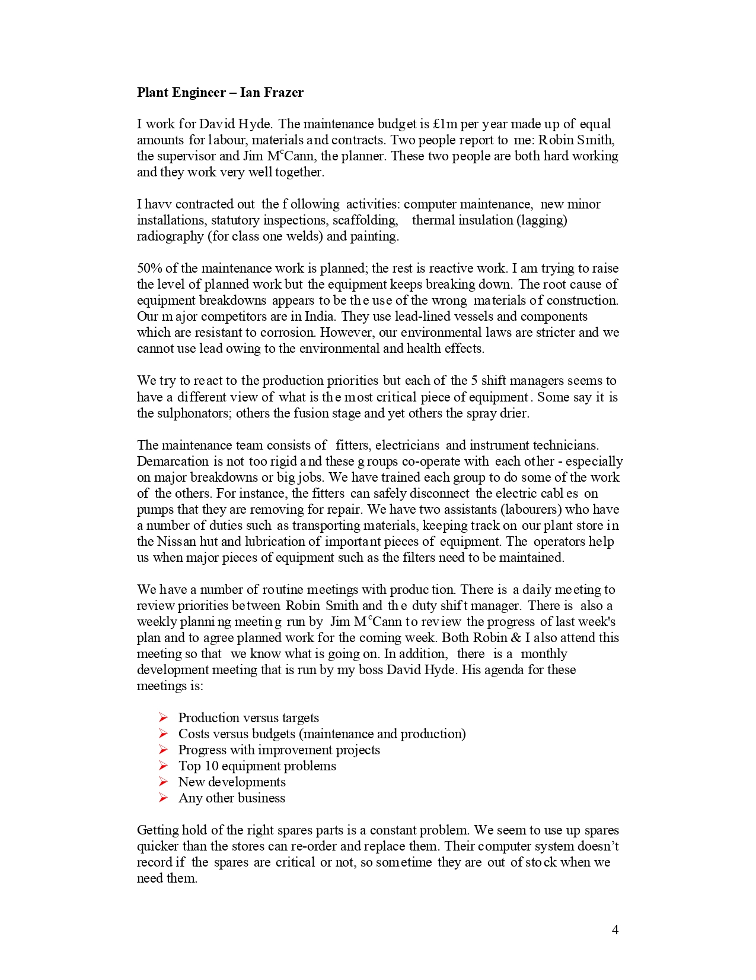

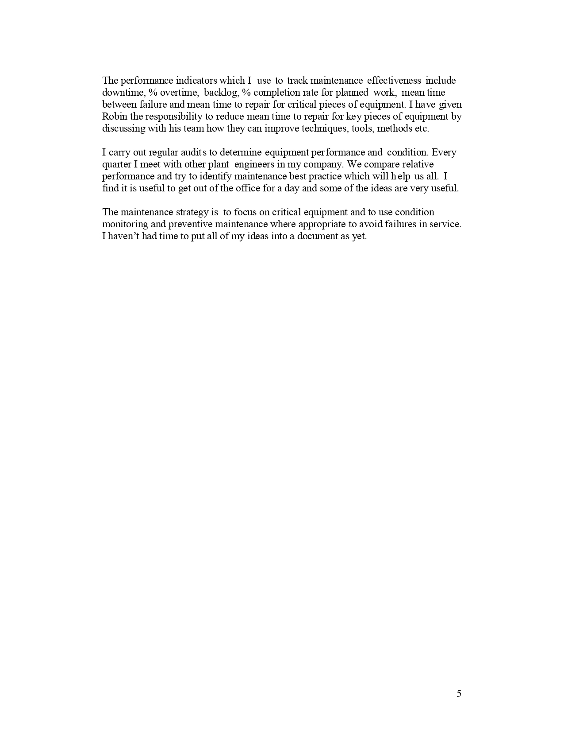

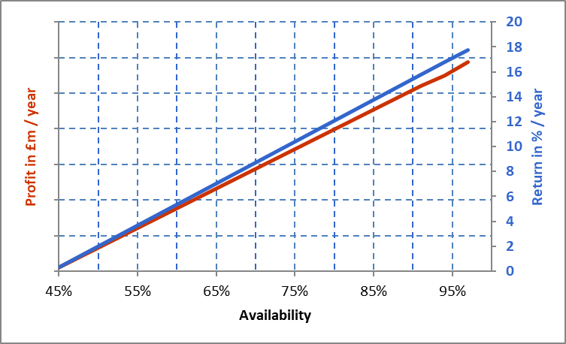APPENDIX 7: FINANCIAL ANALYSIS

|  |  |  |
| --- | --- | --- |
| Availability | Profit in £m | ROI in % / yr |
| 97% | 5.9 | 18 |
| 94% | 5.5 | 17 |
| 91% | 5.2 | 16 |
| 44% | 0.0 | 0 |
| With Yield @ 44% & Quality @ 100% | | |

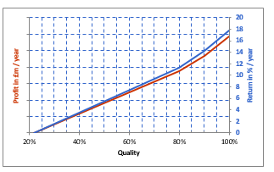

|  |  |  |
| --- | --- | --- |
| Quality | Profit in £m | ROI in % / yr |
| 100% | 5.9 | 18 |
| 90% | 4.7 | 14 |
| 80% | 3.7 | 11 |
| 22% | 0.0 | 0 |
|  |  |  |
| With Yield @ 44% & Availability @ 97% | | |

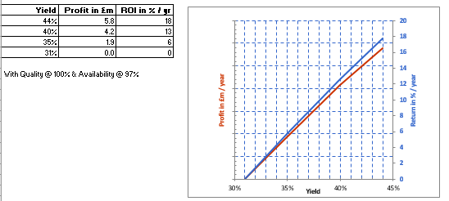

# **APPENDIX 8: PERFORMANCE CUBE**

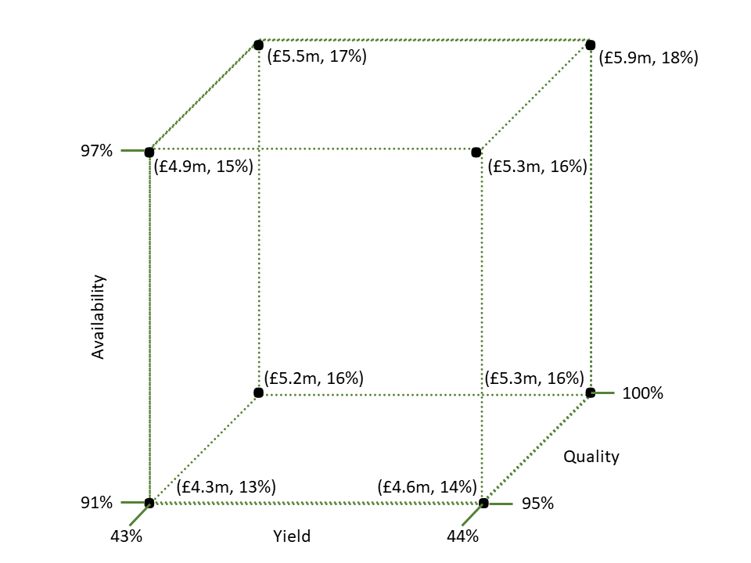

# APPENDIX 9 MATURITY SCORES AND BENCH MARK DATA

|  |  |  |  |  |  |
| --- | --- | --- | --- | --- | --- |
|  | #1 | #2 | #3 | BEST | AVERAGE |
| STRATEGY & POLICY | 2 | 2.5 | 2 | 5 | 2.166667 |
| ORGANISATION | 4 | 3.8 | 3 | 5 | 3.6 |
| COMMUNICATION | 4.5 | 3.5 | 3.5 | 5 | 3.833333 |
| INVOLVEMENT & ENGAGEMENT | 3 | 3 | 3.5 | 5 | 3.166667 |
| WORKLOAD MANAGEMENT | 2.5 | 3.2 | 3.5 | 5 | 3.066667 |
| MAINTAINANCE REGIME | 2.5 | 2.5 | 2.5 | 5 | 2.5 |
| SAFETY, HEALTH & ENVIRONMENT | 2.5 | 1.3 | 0.5 | 5 | 1.433333 |
| MATERIALS MANAGEMENT | 1.5 | 2.5 | 1 | 5 | 1.666667 |
| VALUE FOCUS | 2.5 | 2 | 2.5 | 5 | 2.333333 |
| PERFORMANCE MANAGEMENT | 2.5 | 3.8 | 3 | 5 | 3.1 |
|  |  |  |  |  | 30.86667 |